Faculty Profile
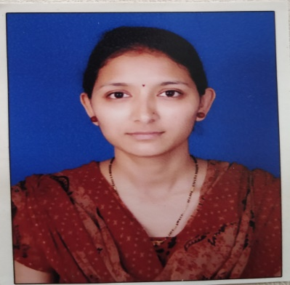
- Name of Faculty: SANYOGEETA BHAGWAN PURI
- Present Position : LECTURER
- Address : RAMDEV PARK, MIRA ROAD, THANE
- Mobile No. : 9730874084
- E-Mail Id : sanyogeeta.puri@gmail.com
- Date of joining (Govt of Maharashtra) : 10/7/2012
(Govt. Poly. Mumbai) : 16/1/2014

- Total Teaching Experience in years: 9 years

- Memberships of professional organizations/Bodies : ISTE

QUALIFICATIONS: (Graduation and Onwards)

Sr.  No. | Degree | University | Class Award | Year of Passing
01 | BE | SRTMU, NANDED | First class | 2010
02

CAREER DETAILS:

Sr. No. | Organization | Designation | Duration | Period | Work Done in Brief
01 | Government Polytechnic, Osmanabad | Lecturer | 10/7/2012 to 15/1/2014 | 1 year, 6 months | -
02 | Government Polytechnic, Mumbai | Lecturer | 16/1/2014 till now | 8 years | Committee member for FC and ARC, Departmental Exam Coordinator for online exam.

TRAINING COURSES ATTENDED:

Sr. No. | Course Name | Duration | Place | Training Agency | Remarks
1 | Internet of Things | 5/12/2016 to 9/12/2016 | GP MUMBAI | GP MUMBAI
2 | Problem Based Learning | 25/6/2018 to 29/6/2018 | GP MUMBAI | GP MUMBAI
3 | Induction Programme Phase I | 26/11/2018 to 7/12/2018 | GP MUMBAI | GP MUMBAI
4 | Induction Programme Phase II | 10/12/2018 to 21/12/2018- | GP MUMBAI | GP MUMBAI
5 | Tools for Online Teaching Learning process | 20/4/2020 to 17/5/2020 | GP JALGAON | MSBTE

Publications : publication of the paper entitled “3D Face Recognition under Expressions, Occlusions and Pose Variation” April-2018

Specialization/ Area of Interest: -

Portfolios handled at institute level (Last 3 years): Online exam

Portfolios handled at department level (Last 3 years): Time table, Parents Meeting, Class Teacher, Exam Coordinator etc

