Faculty Profile
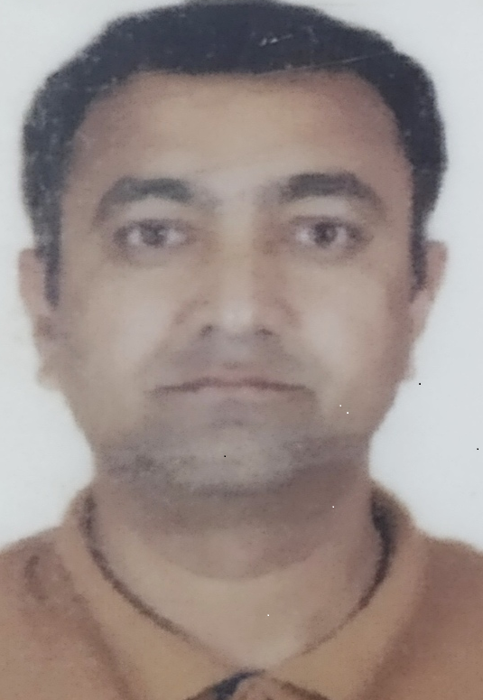
- Name of Faculty: Mr.Vivek Yograj Patil
- Present Position : Lecturer
- Address : 504,Sai Residency,Plot-131,Sector-19,Kharghar Tal- Panvel , Dist-
Raigad 410210
- Mobile No. : 9769872256
- E-Mail Id : vvkpatil@gmail.com
- Date of joining (Govt of Maharashtra) : 30/01/2017
(Govt. Poly. Mumbai) : 30/01/2017

- Total Teaching Experience in years: 18 Years 6 month

- Memberships of professional organizations/Bodies :

QUALIFICATIONS: (Graduation and Onwards)

Sr.  No. | Degree | University | Class Award | Year of Passing
01 | M.Tech | Mumbai | First | 2008
02 | B.E | NMU, Jalgaon | Distinction | 2003

CAREER DETAILS:

Sr. No. | Organization | Designation | Duration | Period | Work Done in Brief
01 | A.C.Patil College of Engineering | Assistant Professor | 12 years 6 Month | 2003-2017 | Student Mentoring, Lab development, Student Counseling.
02 | Government Polytechnic, Mumbai | Lecturer | 5 Years | 2017-till date | Student Mentoring, Lab development, Student Counseling.

TRAINING COURSES ATTENDED:

Sr. No. | Course Name | Duration | Place | Training Agency | Remarks
1 | Induction Training Phase-I | 2 Weeks | Sahaydri Polytechnic,Sawarde,Tal-Chiplun, Dist-Ratnagiri | NITTR,Bhopal
2 | Induction Training Phase-II | 2 Weeks | Sahaydri Polytechnic,Sawarde,Tal-Chiplun, Dist-Ratnagiri | NITTR,Bhopal
3 | Recent Techniques for energy management in Smart Grid(TEQIP) | 1 Week | Nagpur | VNIT
4 | FDP-IoT and Software Architecture(TEQIP) | 1 Week | Lonere | BATU
5 | STTP-NBA Accreditation | 1 Week | Mumbai | NITRR,Kolkata

Publications:

Specialization/ Area of Interest: VLSI Design, Embedded System

Portfolios handled at institute level (Last 3 years): Base line Test coordinator, CAP coordinator.

Portfolios handled at department level (Last 3 years): Department Training and placement Incharge, Class Teacher, Project co-coordinator, In plant training coordinator, NBA criteria 1 and 2 coordinator.

