Faculty Profile
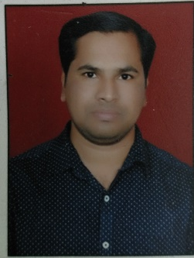
- Name of Faculty: Kiran Zula Dhangare
- Present Position : Lecturer
- Address : Mechanical Engineering Department, Government Polytechnic Mumbai Kherwadi Bandra East
- Mobile No. : 8454849426
- E-Mail Id : kdhangare213@gmail.com
- Date of joining (Govt of Maharashtra) : 15/12/2017
(Govt. Poly. Mumbai) : 15/12/2017

- Total Teaching Experience in years: 12

- Memberships of professional organizations/Bodies :

QUALIFICATIONS: (Graduation and Onwards)

Sr.  No. | Degree | University | Class Award | Year of Passing
01 | BE Mechanical Engineering | North Maharashtra | First | 2009
02 | ME (Machine and Product Design) | Rajiv Gandhi Technical University | First class with Distinction | 2015

CAREER DETAILS:

Sr. No. | Organization | Designation | Duration | Period | Work Done in Brief
01 | AKM Polytechnic Nashk | Lecturer | 1/7/2009 to 31/7/2012 | 3 Years | Academic work
02 | Katgara Polytechnic Bordi | Lecturer | 1/8/2012 to 14/12/2017 | 5 years 4 months | Academic work
03 | Government Polytechnic Mumbai | Lecturer | 15/12/2017 to till date | 3 years 10 months | Academic work

TRAINING COURSES ATTENDED:

Sr. No. | Course Name | Duration | Place | Training Agency | Remarks
01 | Induction Programme Phase I | 26/11/2018 to 07/12/2018 | G P Mumbai | NITTTR Bhopal
02 | Induction Programme Phase II | 10/12/2018 to 21/12/2018 | G P Mumbai | NITTTR Bhopal
03 | Tools for Online teaching and learning process | 20/04/2020 to 17/05/2020 | Online | Department of Pharmacy Government Polytechnic Jalgaon
04` | Environmental sustainability & Green energy | 29/06/202 to 03/07/2020 | Online | Govindrao Vanjari COE Nagpur
05 | Futuristic technologies in Mechanical Industries | 05/06/2020 to 09/06/2020 | Online | Dr. D. Y. Patil institute of engineering Pune

Publications :

Specialization/ Area of Interest:

Portfolios handled at institute level (Last 3 years): Maha DBT coordinator, Student centre activity coordinator

Portfolios handled at department level (Last 3 years): MESA Coordinator, Departmental Exam coordinator, Class teacher

