Faculty Profile
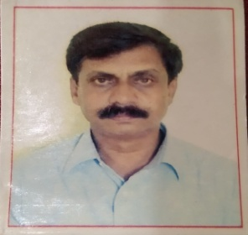
- Name of Faculty: Gaikwad Chandrashekhar Haridas
- Present Position : Lecturer In Electronics
- Address : Govt. Polytechnic Mumbai
- Mobile No. : 9421892079
- E-Mail Id : chgaikwad28@gmail.com
- Date of joining (Govt of Maharashtra): 04/10/1991
(Govt. Poly. Mumbai) : 09/11/2020

- Total Teaching Experience in years: 30 years

- Memberships of professional organizations/Bodies : ISTE

QUALIFICATIONS: (Graduation and Onwards)

Sr.  No. | Degree | University | Class Award | Year of Passing
01 | BE (instrumentation Engg) | Marathwada University aurangabad | I | 1989

CAREER DETAILS:

Sr. No. | Organization | Designation | Duration | Period | Work Done in Brief
01 | G P Amravati | Lecturer In  Electronics | 1991 To 2005 | 14yrs | Teaching
02 | G P Washim | Lecturer In  Electronics | 2005 To 2008 | 03yrs | Teaching
3 | G P Amravati | Lecturer In  Electronics | 2008 To 20014 | 06 yrs | Teaching
4 | G P Yavatmal | Lecturer In  Electronics | 2014 To 2020 | 06 yrs | Teaching
5 | G P Mumbai | Lecturer In  Electronics | 2020 To till date | 14yrs | Teaching

TRAINING COURSES ATTENDED:

Sr. No. | Course Name | Duration | Place | Training Agency | Remarks
1 | Induction Training Phase I | 04 weeks | G P Nagpur | G P Nagpur and TTTI Bhopal
2 | Induction Training Phase II | 04 weeks | TTTI extension centre Pune | TTTI extension centre Pune Pune
3 | Industrial training | 12 weeks | G P Nagpur | G P Nagpur

Publications : Nil

Specialization/ Area of Interest: Power Electronics

Portfolios handled at institute level (Last 3 years): ---
Portfolios handled at department level(Last 3 years): Incharge HOD ETX, Board Exam, Department Academic co- ordinator .

